Project Report Template

1. ITRODUCTION
   1. Overview

Global carbon emissions from fossil fuels have significantly increased since 1900. Since 1970, Co2 emissions have increased about 90%, with emissions from fossil fuel combustion and industrial processes contributing about 78% of the total greenhouse gas emissions increase from 1970 to 2011.

* 1. Purpose

Reducing these Co2 Emission, air pollutants improves air quality and benefits of human health.

1. Problem Definition & Design Thinking
   1. Empathy Map

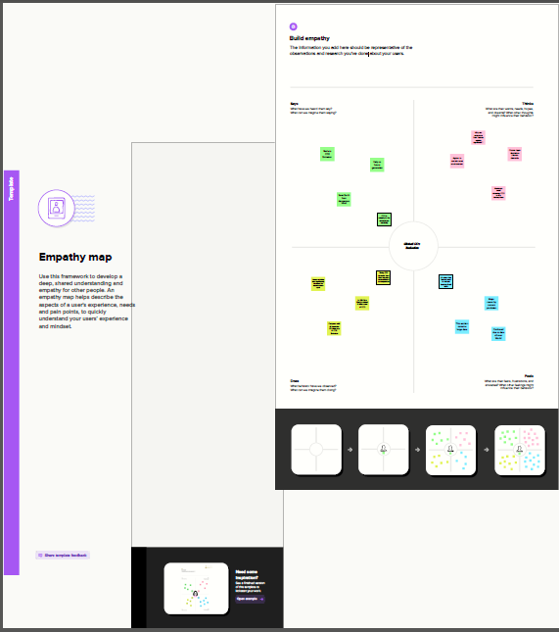

* 1. Ideation & Brainstorming Map

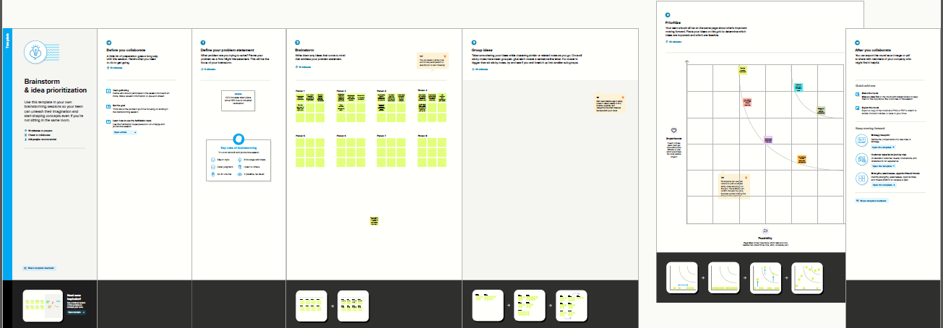

1. RESULT

DASHBOARD

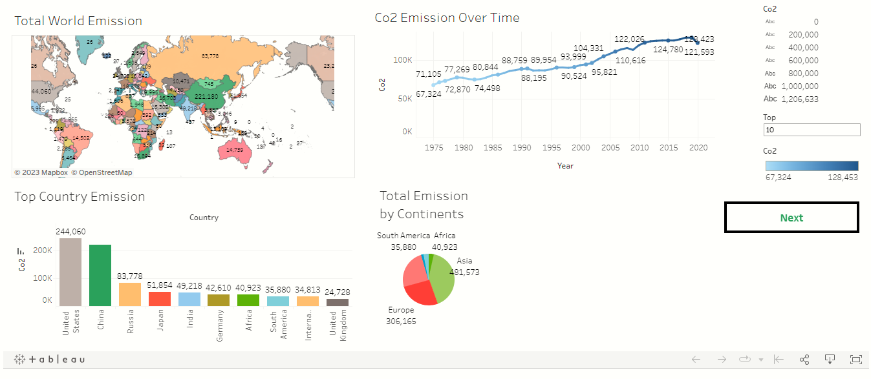

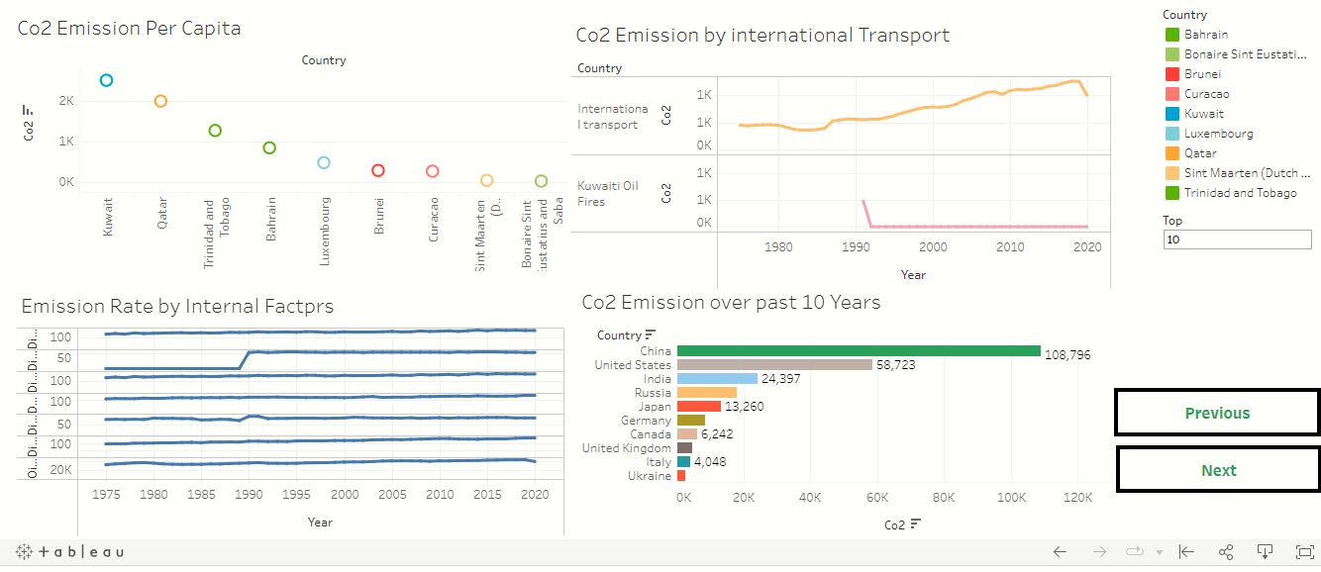

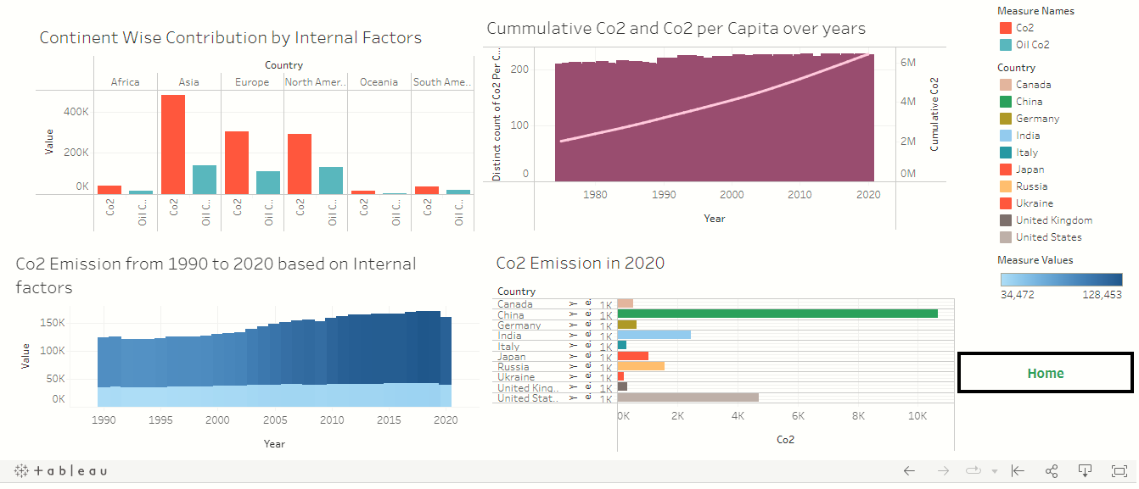

STORY

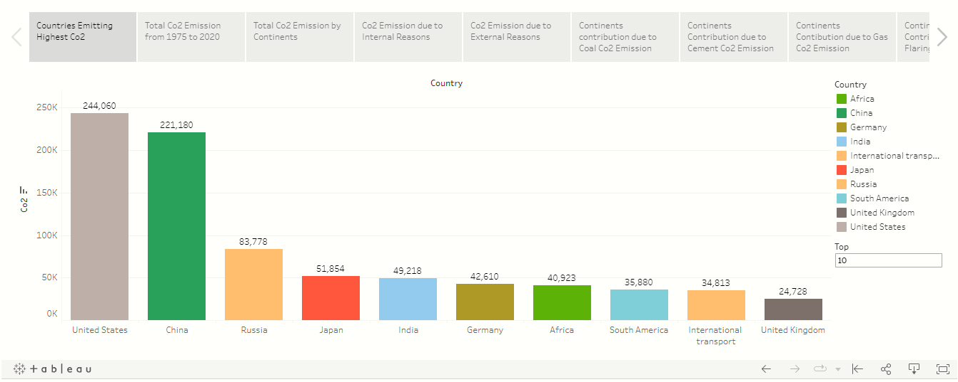

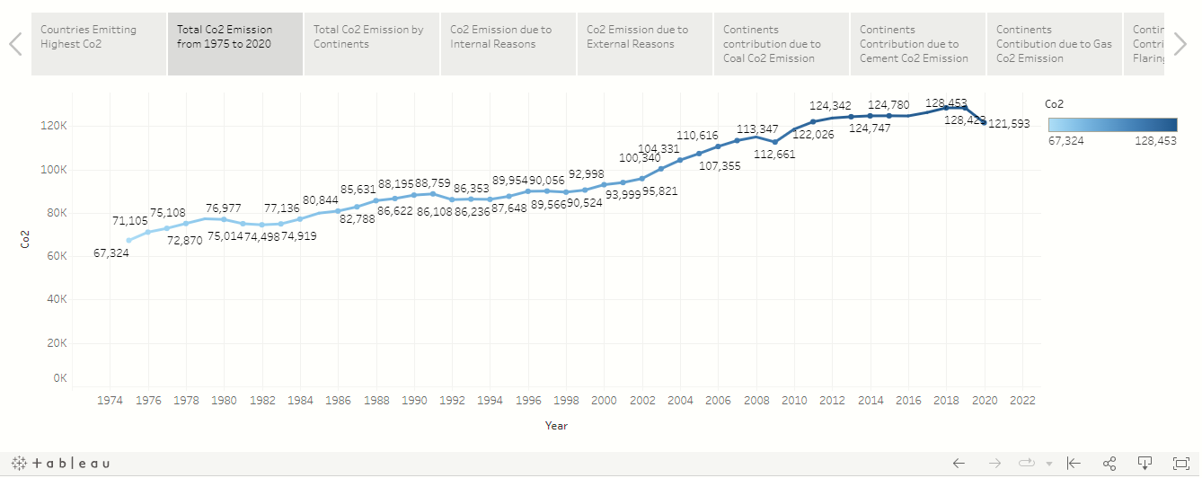

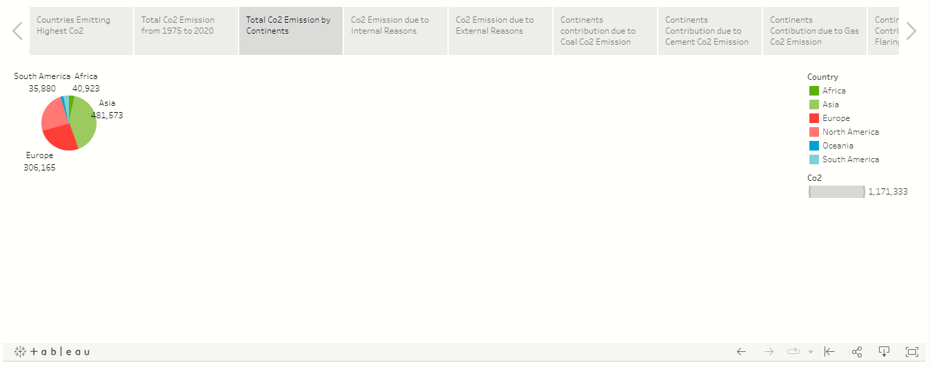

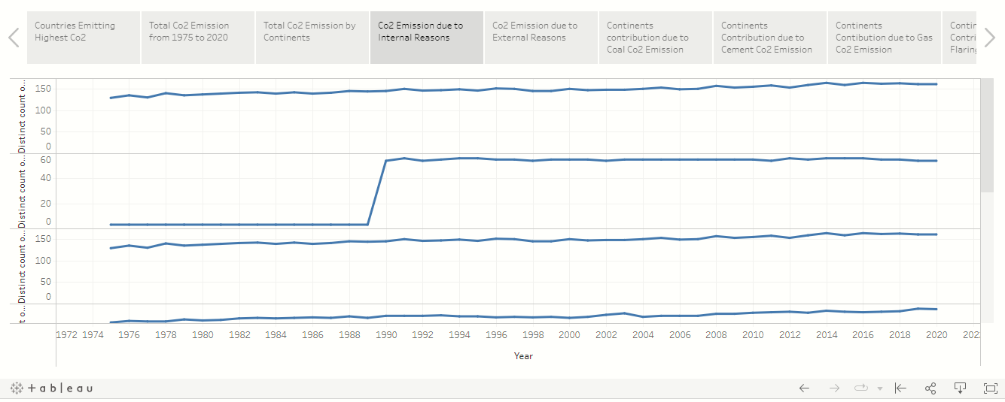

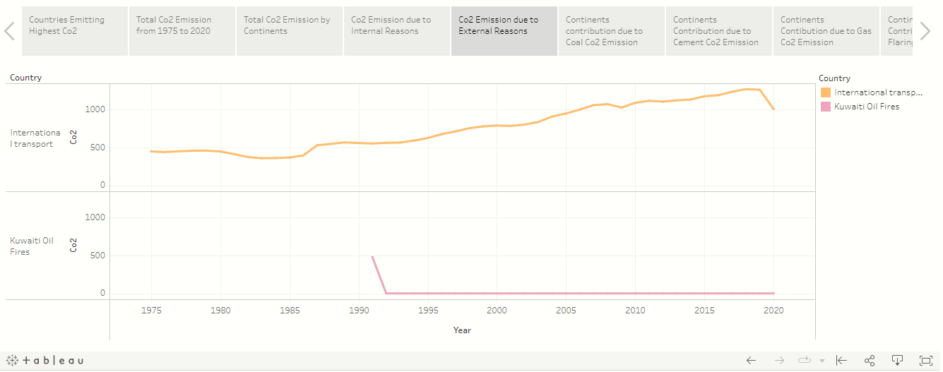

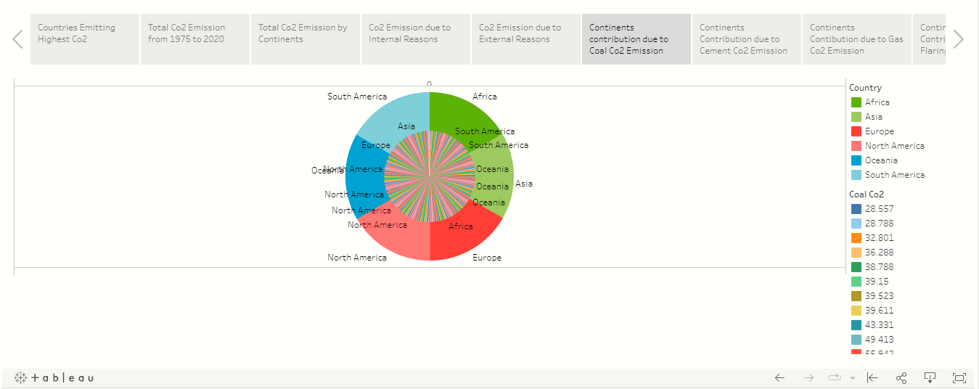

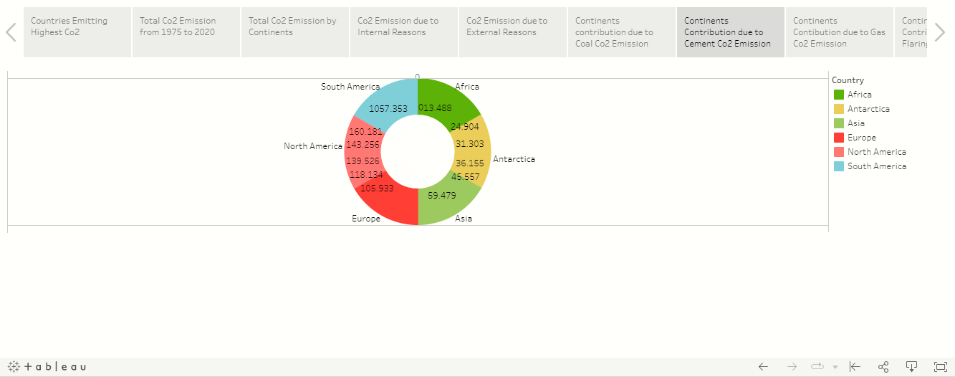

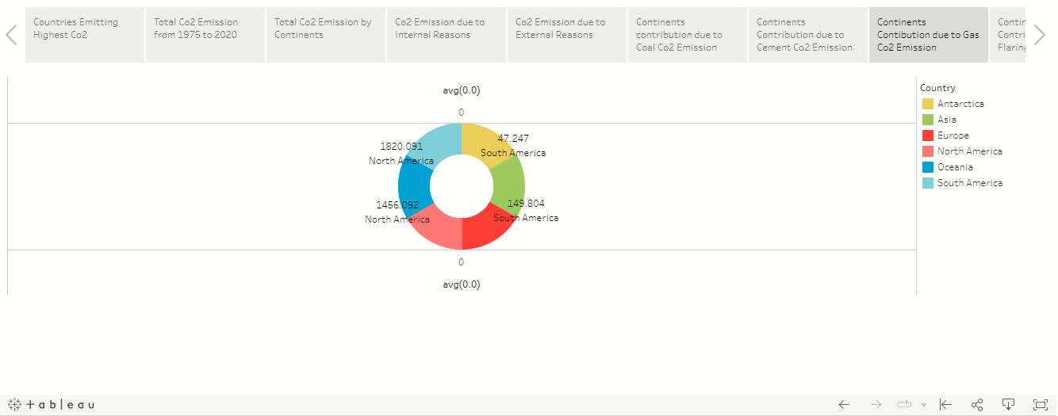

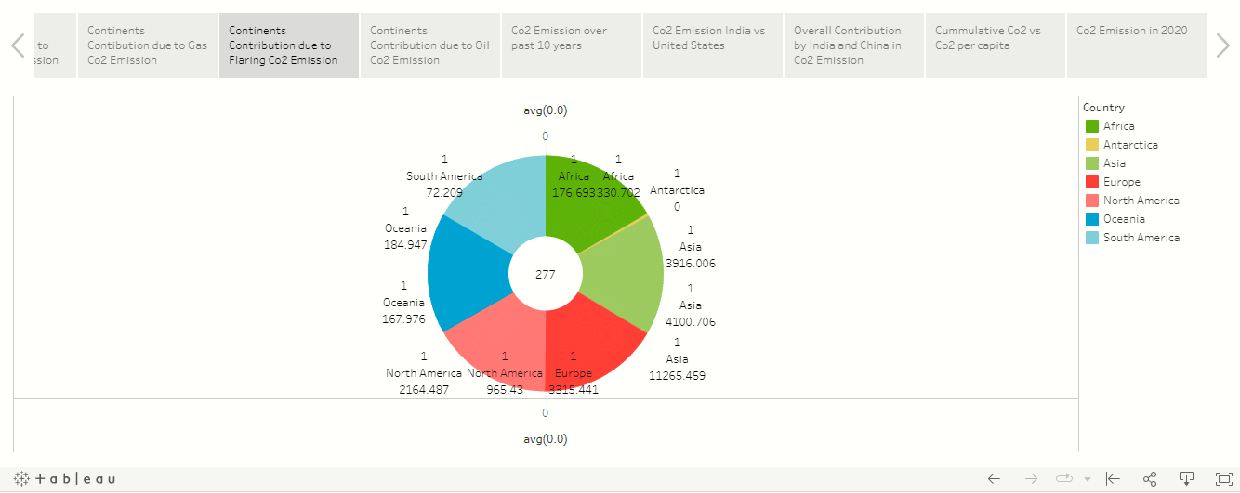

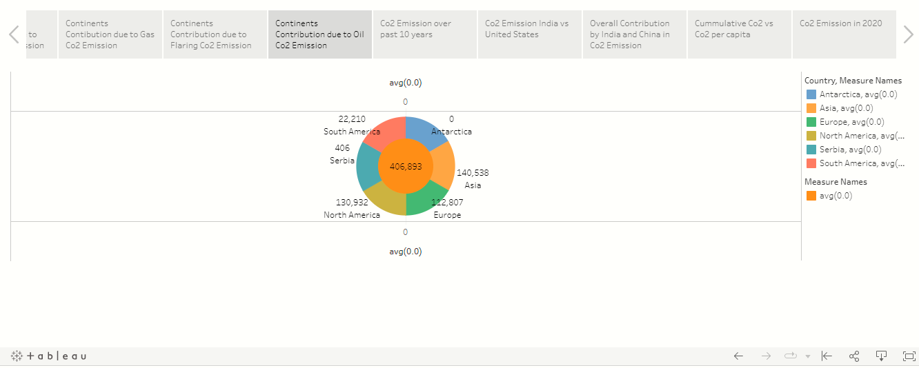

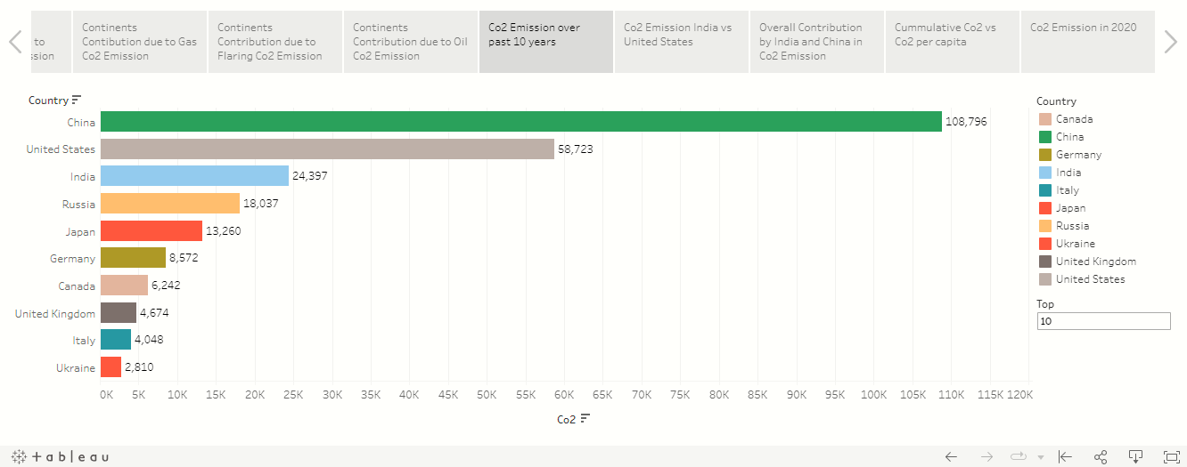

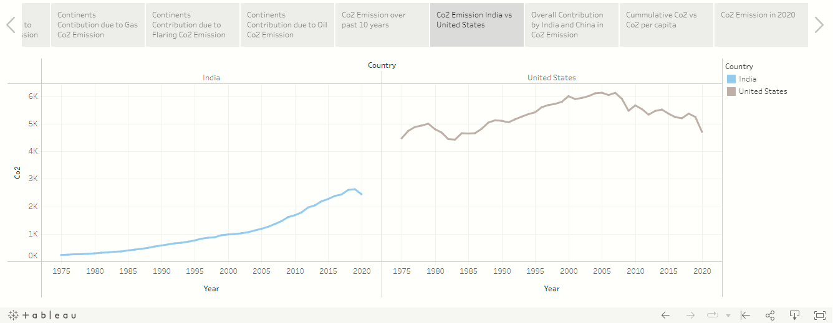

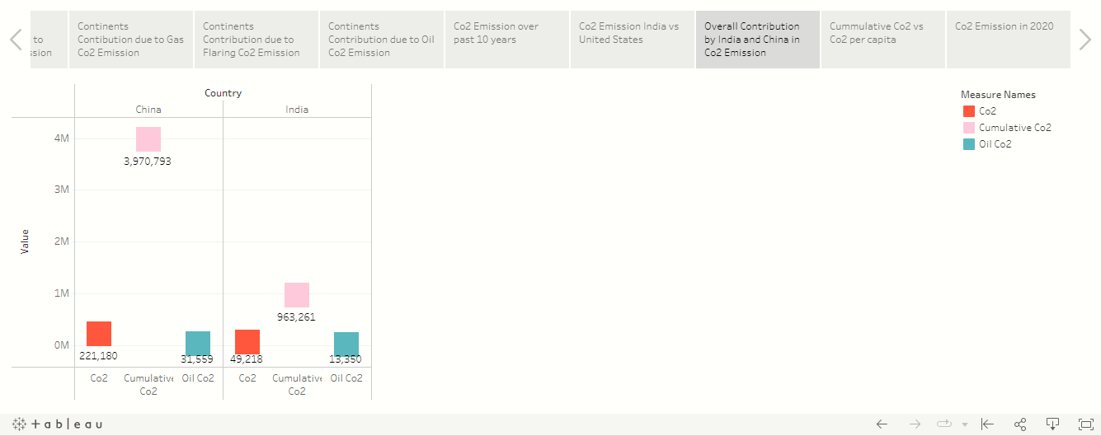

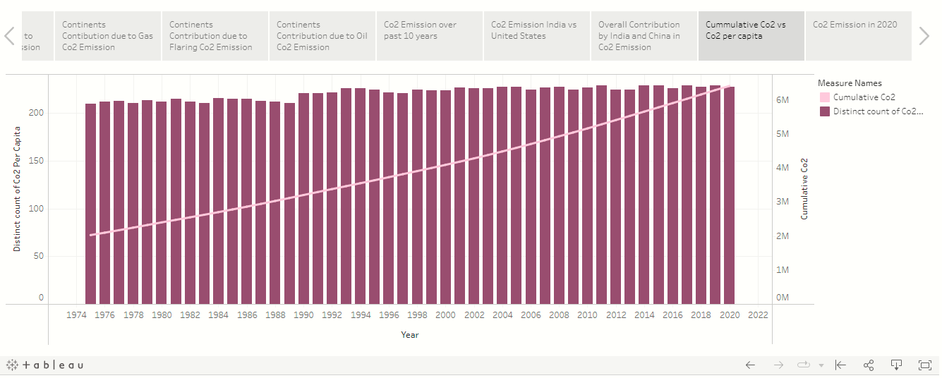

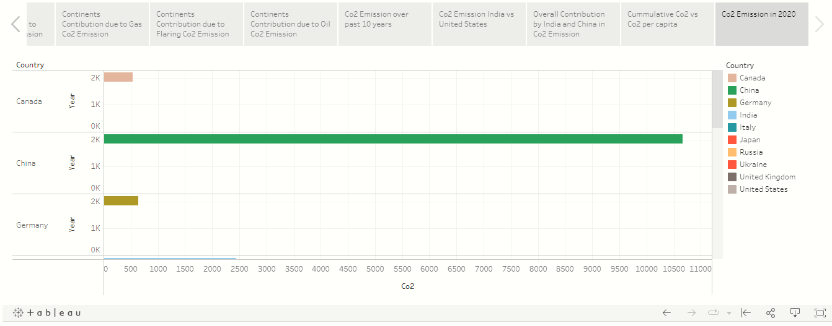

1. ADVANTAGES AND DISADVANTAGES

Advantages:

* Green plants grow faster with more Co2.
* Become more drought- resistant because higher Co2 levels allow plants to use water more efficiently.
* Helps to trap heat in our atmosphere.

Disadvantages:

* Co2 gas can be toxic and very harmful to humans.
* It increases the temperature of the Earth’s atmosphere.
* It causes the global warming effect that has bad effects on Earth.

1. APPLICATIONS

PLANTING TREES is among the most inexpensive, natural ways to take climate action and reduce our negative environmental impact.

1. CONCLUSION

To achieve the two-degree target with a probability of around 70%, it is estimated that global greenhouse gas emissions need to decrease by 50%-60% from 2000 to 2050, and by almost 100% by 2100.

1. FUTURE SCOPE

By reducing Co2 emission, in future Human can survive without hardness.

1. APPENDIX

